AWS Serverless Data Pipeline: Real-Time Salary Aggregation Using S3 and Lambda Tutorial

# 1. Creating a source bucket for incoming CSV files:

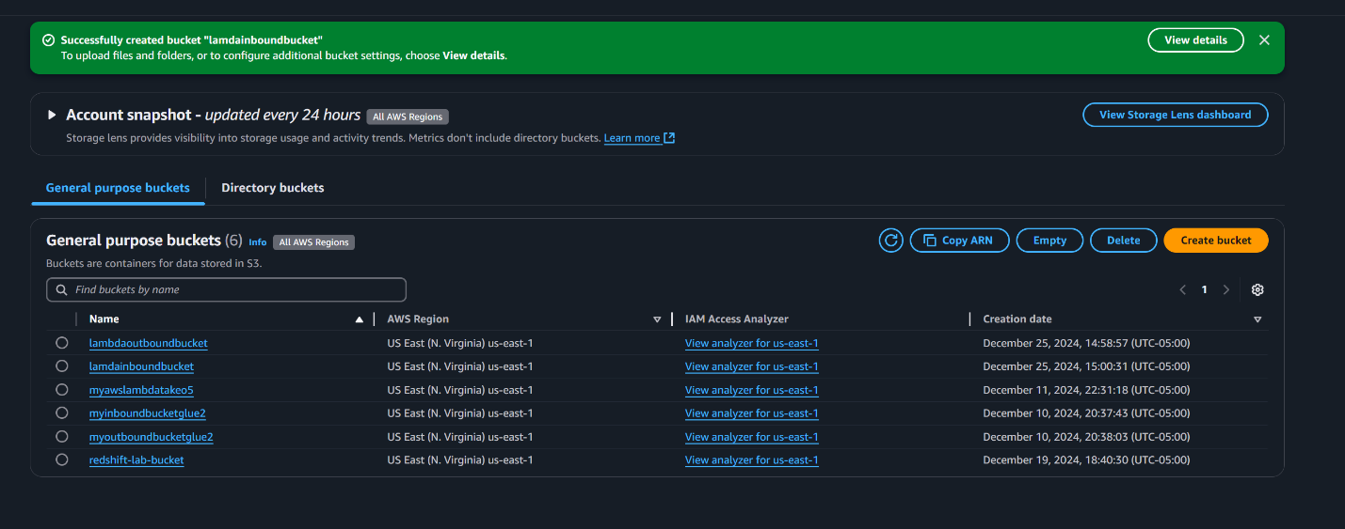

# 2. Creating a destination bucket for storing output files:

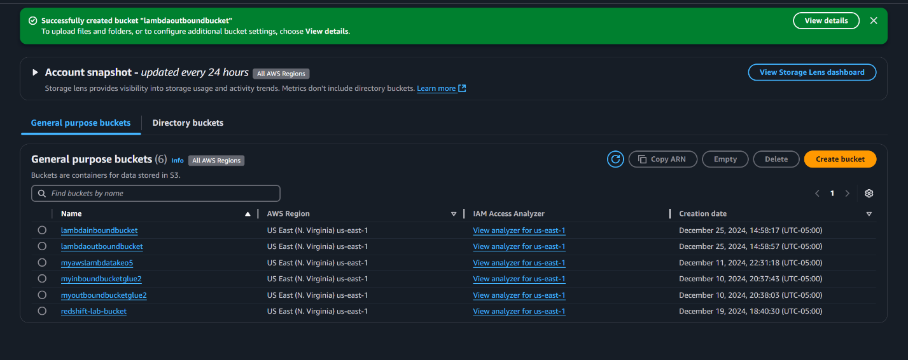

# 3. Creating an IAM role:

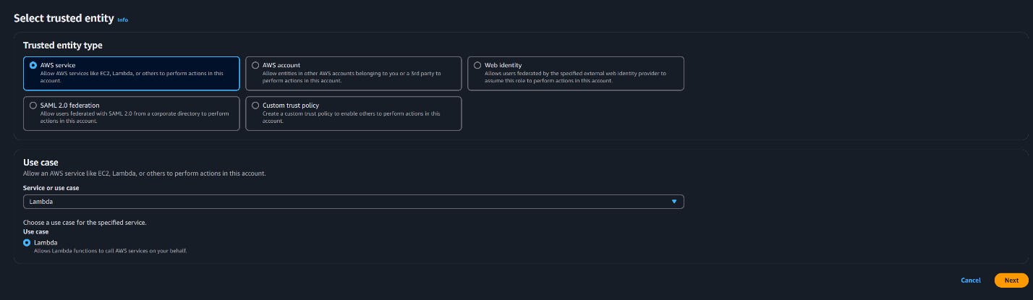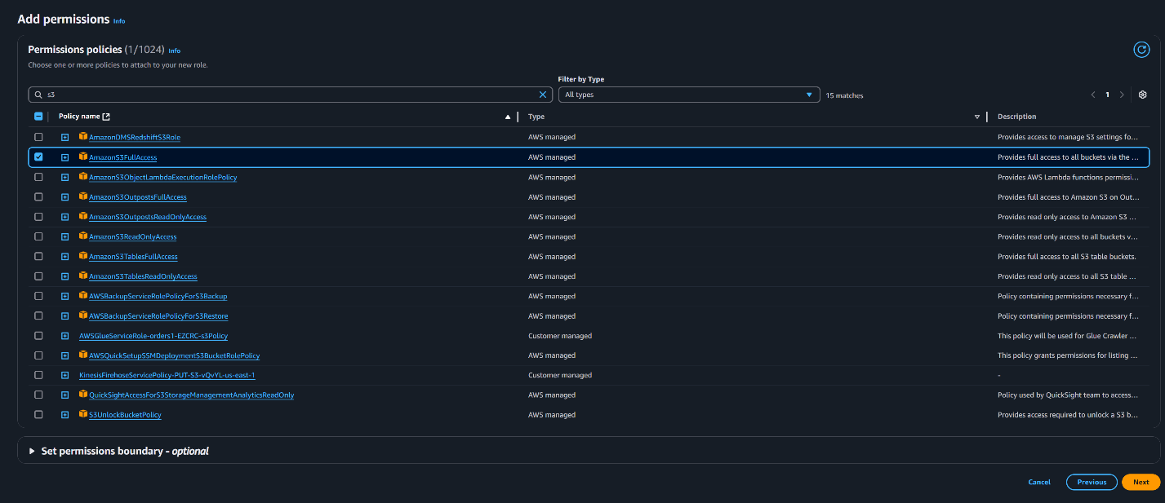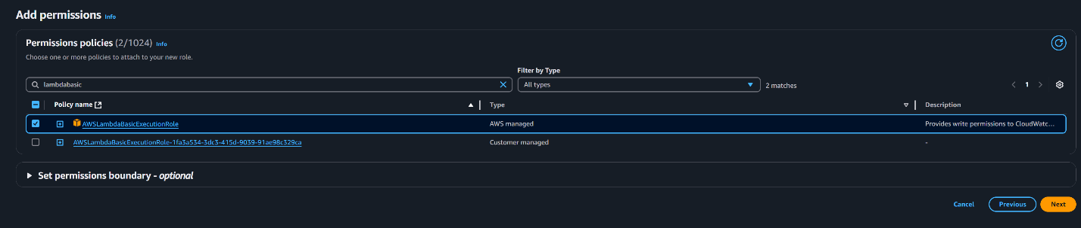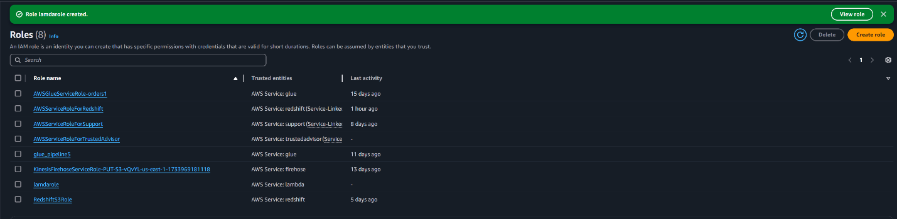

# 4. Creating a lambda function:

# 

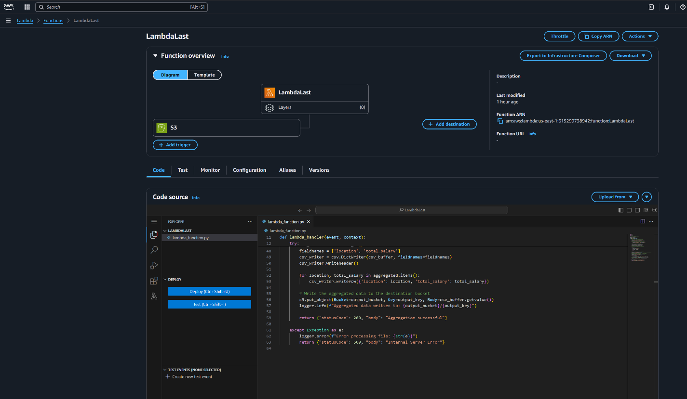

# 5. Creating a trigger on lambda function:

# 

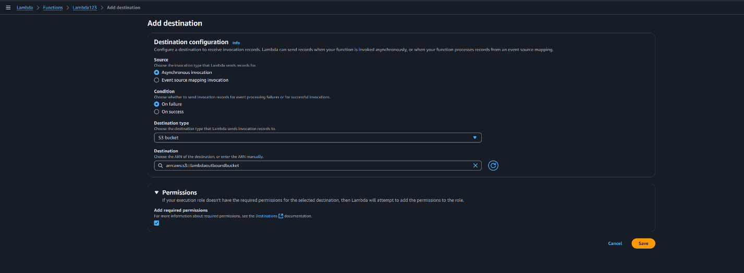

# 6. Creating an event notification

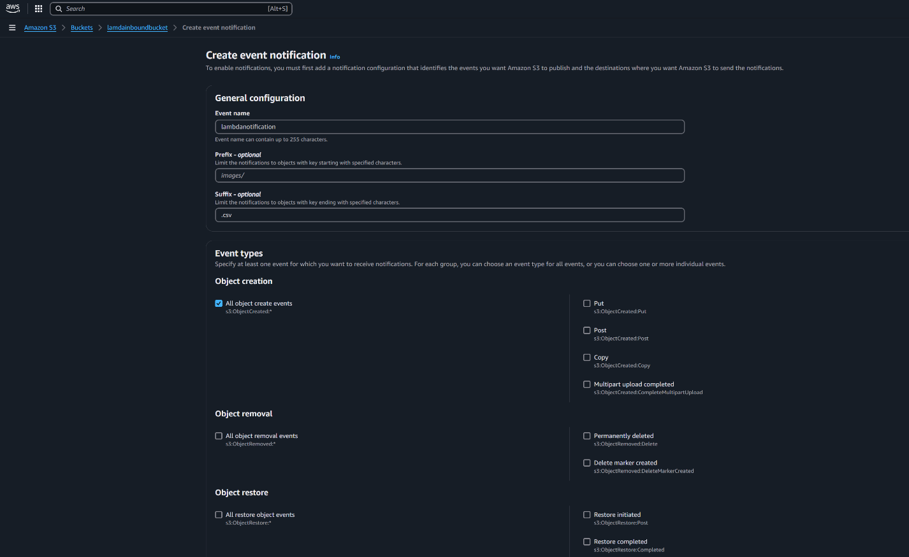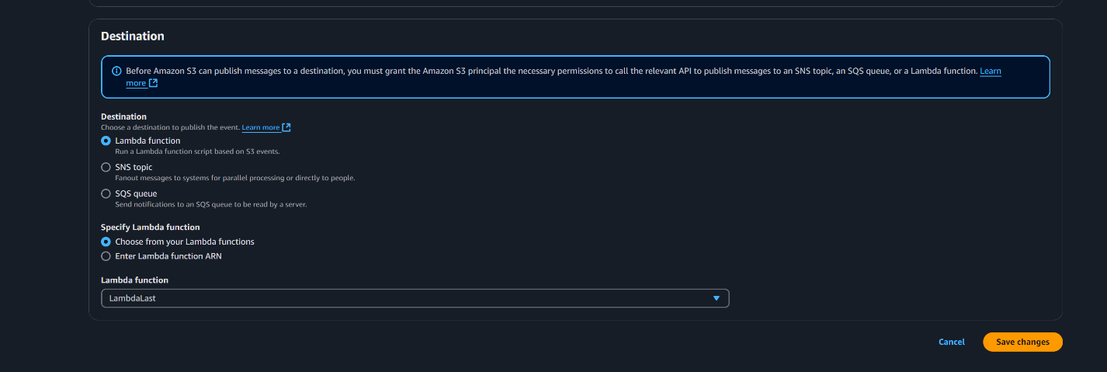

# 7. Testing the pipeline with sample CSV file:

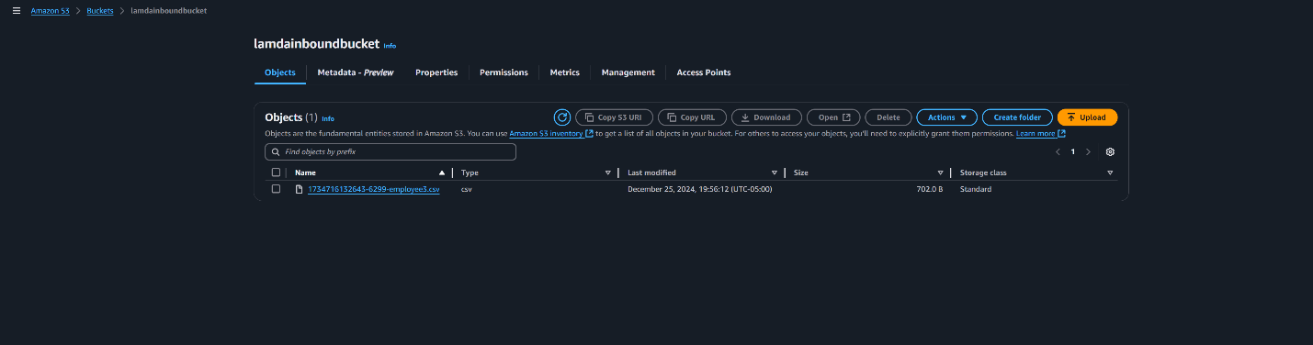

# Output:

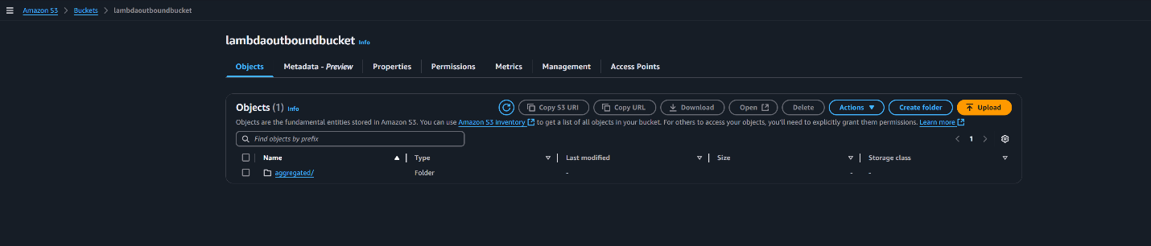

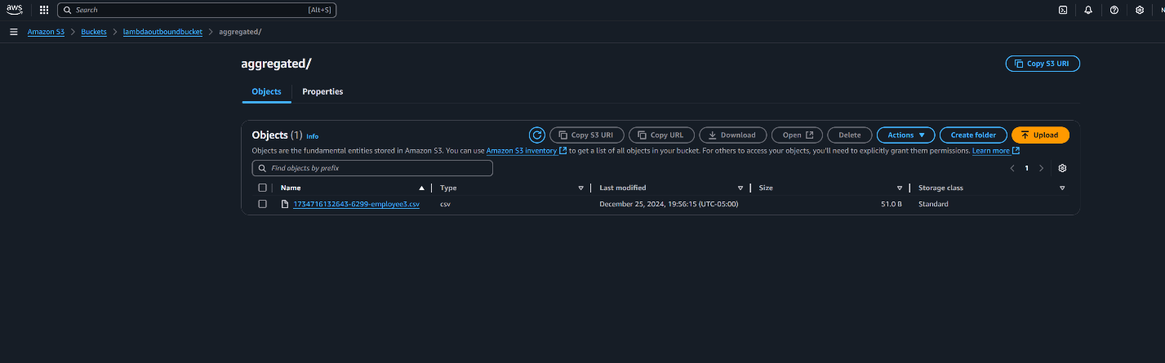

# 8. Showing CloudWatch Logs:

